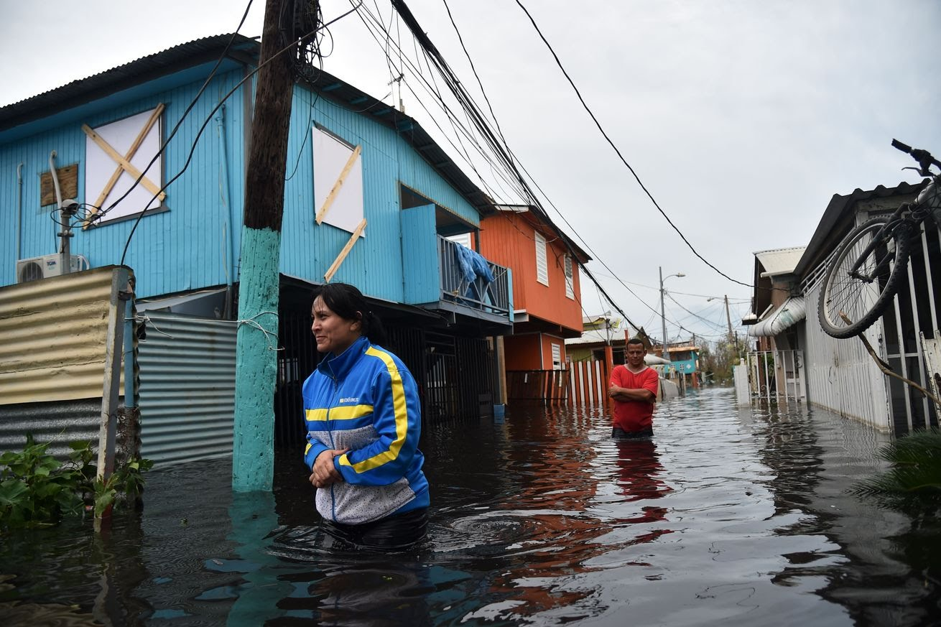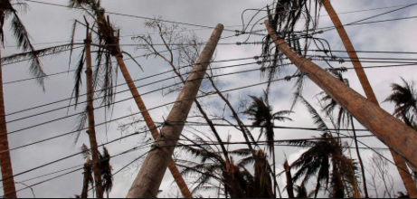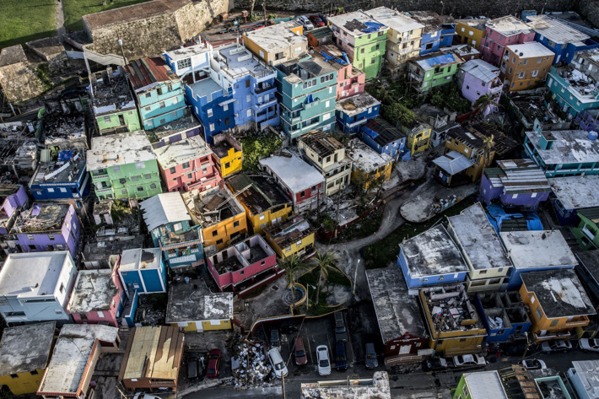

Collection Items

* Generators
* Water
* Canned goods
* Non-perishable consumable goods
* Baby food
* Baby wipes
* Diapers (children and adults)
* D Batteries
* Approved plastic gas containers
* Mosquito repellent
* Trash Bags
* Disposable silverware
* Disposable bowls and plates
* Disposable cups
* Zip-lock type bags

Humanitarian Aid

for

Puerto Rico

After Hurricane Maria

# Collection will run from October 7-23

For more information or to arrange for GENERATOR(s) pick up, contact

________________________

________________________.